
BOGNOR REGIS TOWN COUNCIL
TOWN CLERK Glenna Frost, The Town Hall, Clarence Road,
Bognor Regis, West Sussex, PO21 1LD
Telephone: 01243 867744
E-mail: clerk@bognorregis.gov.uk

Dear Applicant,

I would like to take this opportunity to thank you for taking an interest in the position of Allotments & In Bloom Officer for Bognor Regis Town Council. If you are unfamiliar with our town, please take the time to visit our website (www.bognorregis.gov.uk), which gives information both about Bognor Regis and the work of the Town Council.

The interview panel will be shortlisting applicants using the person specification within the enclosed application pack. Please note that all applicants must complete and return the application form, available on the Town Council website, to be considered for shortlisting. CVs will not be accepted.

Completed forms can be returned either by sending as an attachment in an email to glennafrost@bognorregis.gov.uk or addressed to me by post and should be received by no later than 5pm on Thursday 8th May 2025. It is anticipated that interviews will take place on Monday 19th May 2025.

Only shortlisted candidates will be notified, therefore, if you have not received an invitation to interview within one month of the closing date, I regret that on this occasion your application has been unsuccessful.

I wish you well in your application.

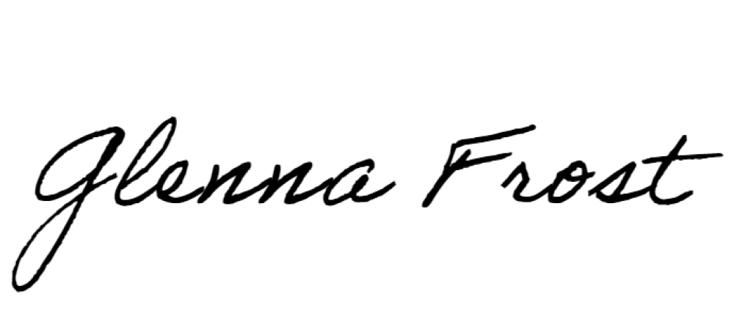
Yours sincerely,

Glenna Frost
Town Clerk

